**Open Source Graphics & Animation Tools**

**MID-SEM EVALUATION**

**MARCH 2020**

**Submitted to**

**Dr. Durgansh Sharma**

**Professor, Cybernetics SCS, UPES**

**Submitted By**

Name: Tushar Singhal

Roll No: 63

SAP ID: 500068249

B. Tech CSE (OSSOS) Department of Cybernetics

COMPUTER SCIENCE & ENGINEERING



**School of Computer Science**

**University of Petroleum and Energy Studies,**

**Dehradun – 248007: Uttarakhand**

Table of Contents

Phase- 2: 3

Project on Blender 3

Topic: Jungle with Mowgli 3

Procedure: 3

# Phase- 2:

# Project on Blender

# Topic: Jungle with Mowgli

## Procedure:

Step1: First open new project now removes the object b using right click delete.

Step2: Press Shift+A and add plane from mesh.

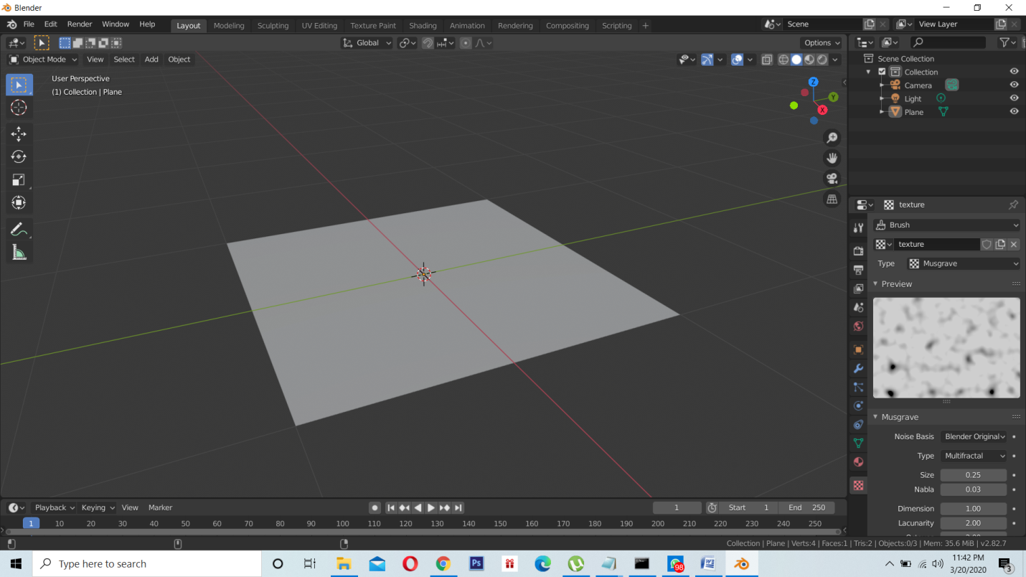

Step3: Now we must put the camera into center and looking downward to do that click on camera and press alt r and alt g.

Step4: To attach camera to the curve we use object constraints.

Step5: Now adjust offset value and X axis and Y axis value to give your model a mountain type view.

Step6: Now set depth of the mesh so that it give a realistic view.

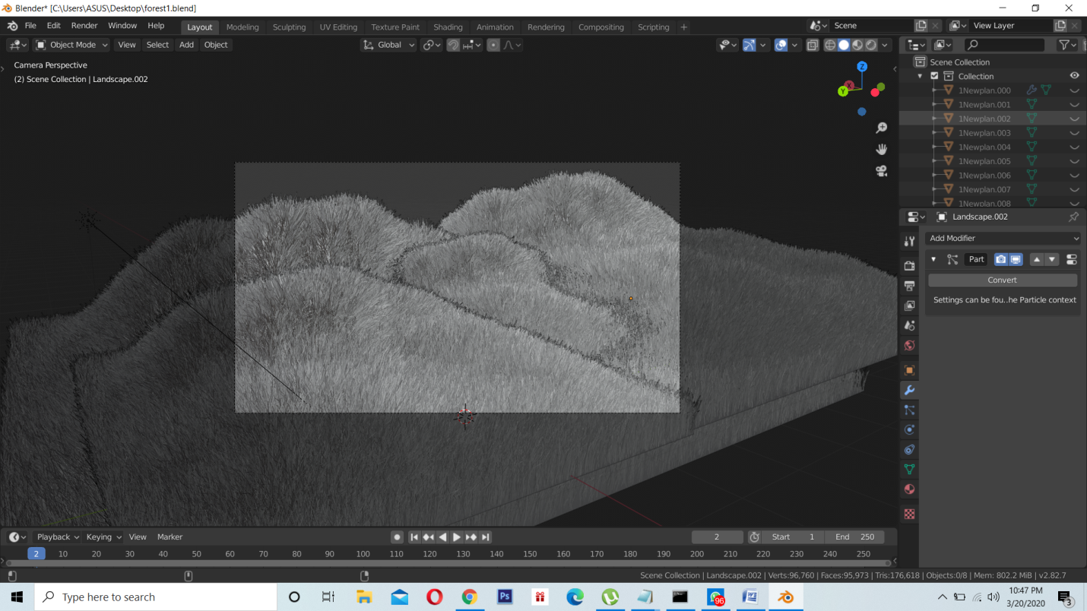

Step7: Using particle system we add a hair addon and then color the mesh green

Step8: Model the flowers and trees. Color them accordingly

Step9: Now add trees and color it according to your choice

Step10: Now use Shift+D to duplicate the grass and tress and add it on the whole mesh.

Step11: The color must be added from the material menu where we use principal shaders.

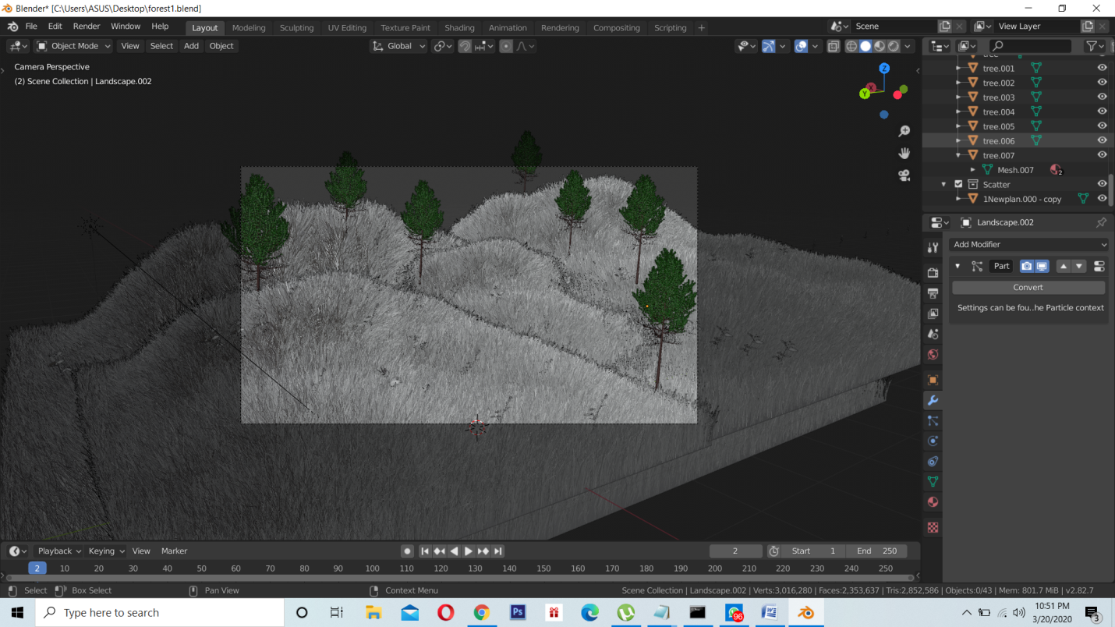

Step12: In viewport shading you can view your color and change it from material menu if it is not suitable.

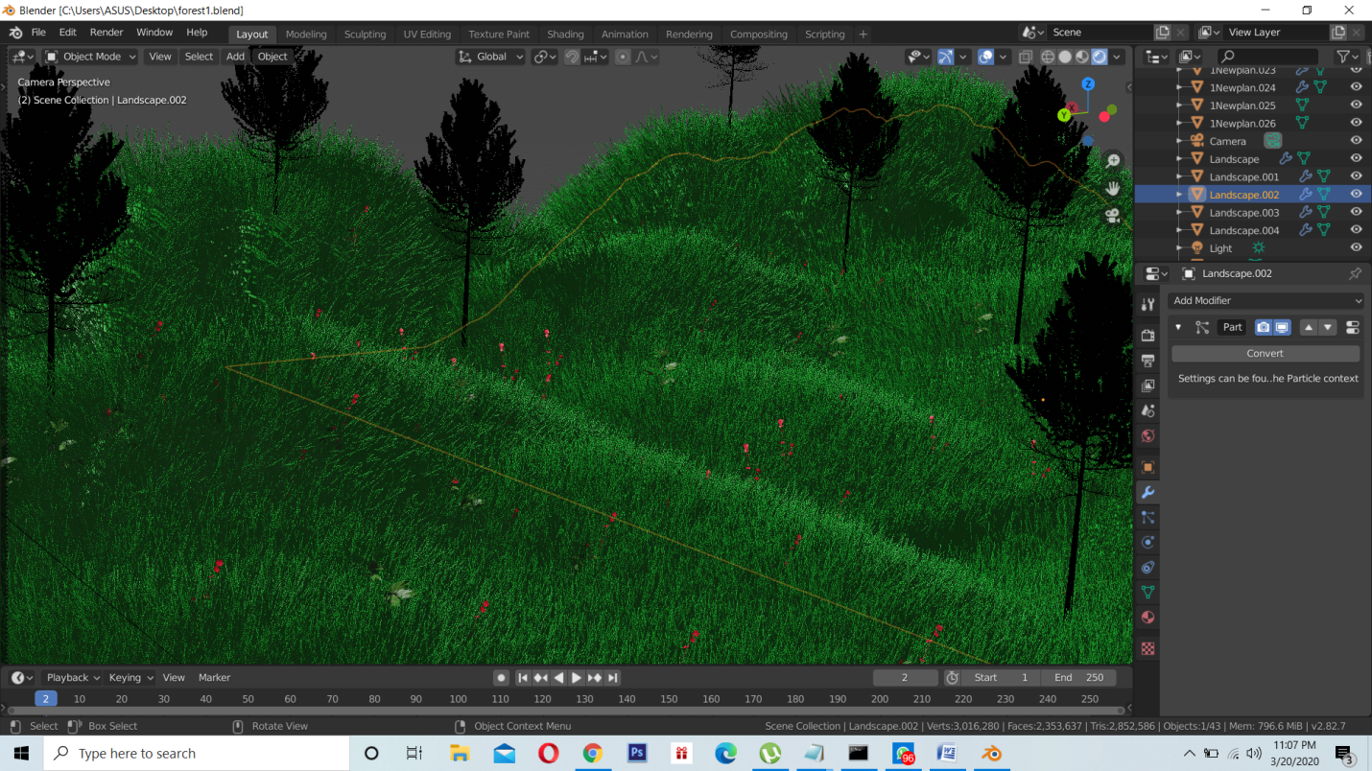

Step13: Now render the image in Eevee as this is real time render and it will give you the real colors you selected.

Step14: Here is the rendered output.

**Final View:**

